Plymouth Congregational United Church of Christ
Fifth Sunday after the Epiphany

February 4th, 2018 9:30 a.m.

A Just Peace Church
An Open and Affirming Congregation
A God is Still Speaking Congregation

Our faith is 2000 years old; our thinking isn’t.

Welcome to Worship!
We are grateful for your presence this morning. If you are new to Plymouth Congregational United Church of Christ, the following information may be helpful.

- We are an Open & Affirming congregation where all people are valued and accepted regardless of sexual identity or orientation.
- We are a Just Peace church that affirms that peace is possible in human history and prays ceaselessly that peace may prevail on Earth.
- We celebrate our Christian heritage and seek to follow the teachings of Jesus Christ.
A Special Word to our Visitors
- Please fill out the fellowship pads the ushers will hand out at the beginning of the service. We would love to get to know you better and keep you up-to-date on all the programs, events and activities offered throughout the year.
- Families with infants and children are especially welcome to our service. Childcare is available during the worship service in the nursery. Please speak with an usher if you need assistance to find our nursery.
- Children’s bulletins, activity bags (to be returned after worship) and toys are available in the Narthex. To find out more about our Sunday school program, we may talk to our Faith Formation Director Cindy Bjerklie or visit our website.
- Our service can be heard in the parlor, library and nursery.
- Our sanctuary is equipped with the Telecoil Loop System for the hard of hearing. For assistance on how to connect to the Telecoil, please speak to one of our ushers.
- Our building is fully accessible to all people. A small parking lot on the south side of the church is available only to persons with limited mobility or physical disability. The entrance to the parking lot is located immediately behind the Post Office, off Highland Street. An elevator connects all three levels.
- Join us for Coffee Hour in the fellowship hall immediately after the service.

Help us to protect the environment by dropping your bulletin in one of the recycling baskets at the two main entrances to the sanctuary. You may also download your bulletin from our website and follow the service on your own mobile device.
Large print bulletins are also available.
Transcripts of our Sunday Sermons and videos of the worship services are available on our website, www.uccplymouth.org.
Our worship service is live-streamed on our Facebook page every Sunday.

GATHERING

Prelude Reflection Kerry J. Beaumont
The beginning of the prelude is an invitation to silent,
personal preparation for the worship of God.

Welcome and Life of the Church

Centering Song Spirit of the Living God

*Call to Worship
*Indicates congregation standing
One: Make a joyful noise to the Lord, all the earth.
All: Worship the Lord with gladness; come into God’s presence with singing
One: Know that the Lord is God. It is God that made us, and we are God’s creation; we are all God’s people.
All: Enter God’s House with thanksgiving and praise. Give thanks and bless God’s name. For the Lord is good; God’s steadfast love endures forever, and God’s faithfulness to all generations.

*Hymn “O for a Thousand Tongues to Sing” Blk#42

Prayer of the Day
One: Let us confess our sins against God and each other:
All: Good and gracious God, we have promised to live as your people. Yet we confess that we fail you and one another when we do not honor one another as we should, when as the Body of Christ we are often divisive, when we do not work together as one to your glory, or when we are silent in the face of evils of hatred and hostility in the world we live in. Lord, have mercy, receive us as we are and forgive us for God’s sake that we may commit ourselves anew to live as those who belong to you; though the grace of our Lord and Savior Jesus Christ. Amen.

Silence for Personal Reflection
God’s Promise of New Life
One: God loves us even when we fail to acknowledge our mistakes; God forgives us even when we cannot forgive ourselves; God shows mercy and compassion even when we quietly condone that the world’s violent ways. Friends, let us announce the Good News of our faith.
All: In Jesus Christ, God searches for us and gives us new life! Behold: the old has gone and the new life has begun! In Christ we are a new creation! Alleluia!

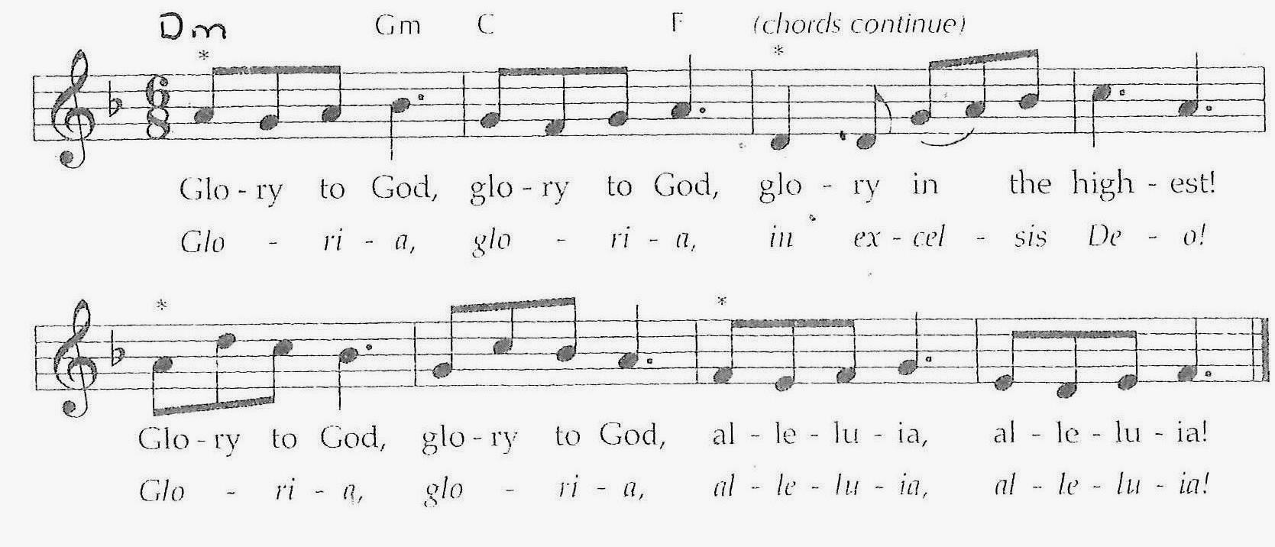
Prayer Response “Glory to God”

*Sign of Peace
One: Since we are no longer strangers but sisters and brothers in Christ, may we show the world how to live as both peace-lovers and peace-makers.
All: May the peace of Christ be always within us, among us, before us, behind us, over us, and all around us.
One: Let us greet one another with the sign of peace.
Children’s Message
HEARING THE WORD
Scripture Lessons
One: Listen for the Word of God
Hebrew Lesson Ecclesiastes 3:1-11, 20 OT p.575
Gospel lesson John 14: 1-4, 18-19 NT p. 938-939

One: May God bless our reading, hearing, and doing of God’s holy word.
All: Amen

Special Music Somewhere Over the Rainbow

Sermon ”Somewhere in Time, a Place To Call Home”

*Hymn “Some Glad Morning” Blk#595

RESPONDING TO THE WORD

Prayers of the People

The Lord’s Prayer
All: Our Father, who art in heaven,
hallowed be thy name.
Thy Kingdom come;
thy will be done on earth as it is in heaven.
Give us this day our daily bread.
And forgive us our debts,
as we forgive our debtors.
And lead us not into temptation,
but deliver us from evil.
For Thine is the Kingdom, and the power, and the glory, forever. Amen.

Offertory

Gift of Music Precious Lord, Take My Hand

*Doxology Praise God from whom all blessings flow;
Praise God all creatures here below;
Praise God above you heavenly host;
Creator, Christ, and Holy Ghost.

*Unison Prayer of Dedication
All: Merciful and gracious God, of whose bounty we have all received, accept this offering of your people. Remember in your love those who have brought it and those for whom it is given. Follow it with your blessing so that it may promote peace and goodwill among all people and advance the realm of our Lord and Savior, Jesus Christ. Amen.
CELEBRATION OF HOLY COMMUNION
Invitation to the Table
One: May the Living God be with you.
All: The Spirit of God is among us.
One: Open your hearts to God.
All: We open our hearts and minds to the Holy One.
One: People of faith, give thanks to God.
All: It is our greatest joy to offer thanksgiving to our Maker.
One: We come into your presence, Gracious God, as a broken people seeking your mending; as a divided people seeking your unity; as a hungry people seeking the nourishment you alone can give. We rejoice that you call the entire human race to this table of love and forgiveness. We come in remembrance and celebration of the gift of Jesus Christ, whom you sent to bring the Good News of the Kingdom to humankind.

So this morning, in the company of each other, remembering our brothers and sisters gathered around this Table throughout the world, we praise your name, O Lord of life, as generations before us have done signing:
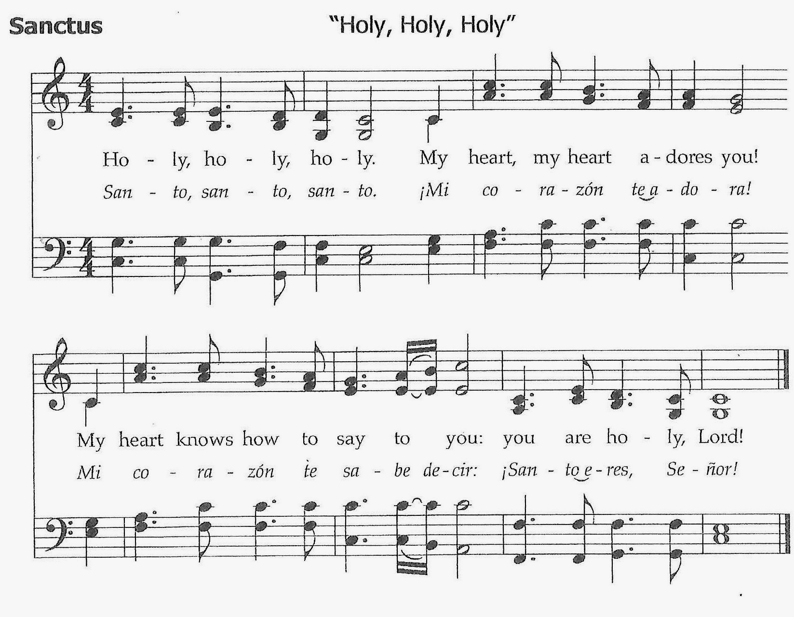

All: Blessed be God, now and forever.
One: Through Christ, with Christ, in Christ, in the unity of the Holy Spirit, all glory and honor are yours, O God, now and forever.
All: Amen.

Breaking of the Bread and the Pouring of the Cup
Sharing of the Bread & the Cup
Prayer of Gratitude after Communion
All: We give thanks, O God, because in your own free gift of love you have reached out to us. You have refreshed us at your table, touched our deepest needs, and called us to a life of discipleship. Send us forth with courage and joy in the name of Jesus Christ, that we, too, may become bread and peace for one another and the world. In his name we dare to pray with the words Jesus taught his disciples, saying:

The Lord’s Prayer
All: Our Father, who art in heaven, hallowed be thy name.
Thy Kingdom come; thy will be done on earth as it is in heaven.
Give us this day our daily bread.
And forgive us our debts, as we forgive our debtors.
And lead us not into temptation, but deliver us from evil.
For thine is the Kingdom, and the power, and the glory, forever. Amen.

SENDING

*Hymn “O God, Our Help in Ages Past” (v1-6) Blk #25
*Benediction

Postlude Schmücke dich, o liebe Seele Georg Philipp Telemann

The Postlude ends our gathered worship and sends us into the world where our true service begins.

Keeping in Prayer
Greg Friel Peggy Suntum Ron Decker
Lynn Anderson Cindy Richard Kersten
Doug Grant Bob Chase Amy Barber
Jesse Armstrong Ginny Arsenault Jack & Vicky Meyers
Pat Andrews Bill Bonney Nancy Pirnie
Hannah Starck

Bob Feeney, our Chicago Seminary Student

If you have any prayer requests, please fill out a prayer card located in the
pew rack and drop it in the offering plate.

Announcements

Staff News
We welcome back Reverend Paulo and all those who went on the Cuba mission trip! We are thankful for a safe and restful return and look forward to hearing about their time spent there.

Faith Formation
Please join us for our Pajama & Pizza Party on March 17, 2018 from 6:00 - 8:00 p.m. All children are invited to wear the pajamas to church and enjoy pizza and the movie, "Paddington Bear". Please RSVP to Cindy Bjerklie a.s.a.p. so we'll know how much pizza to have on hand. We are actively seeking volunteers to help with our children's programs, particularly with teaching Sunday School and music. If you're interested in working with our great kids, please contact Cindy Bjerklie at faithformation@uccplymouth.org.

Kids with a Mission are getting ready to work on their next project and are continuing to collect donations to redecorate their room. If you have extra games, lamps, rugs, chairs, or other items that might be useful please contact Deb Boyer, Ruth Mosher, or Cindy Bjerklie.

Feeding Our Children
Our program to send bags of food home with some of the children at Plymouth Elementary School and the children enrolled in HeadStart is in need of your help. It is time for all of us to make a contribution to this program. The cost for the food is $10.00/week/child that amounts to $40.00/month/child or $460.00/year/child. Think about what you can afford from your budget to help feeding Our Children. Remember there are many hungry children in this rich country and 47 percent of the students at Plymouth Elementary School are on free or reduced price lunch.
Food donations are also always welcome. Can you add one can of corned beef hash or macaroni and cheese or peanut butter. These are always welcome and we need these items every week. Please make a promise to keep our church following its mission, which Jesus said was to feed the hungry. The children will thrive and grow because you cared enough to help. For more information call the church office or Susan Wei.

Buildings and Grounds
Plymouth Church has always been aware of the needs of handicapped people and it has been brought to the attention of the buildings and grounds committee that we needed to upgrade one of the bathrooms in our facility. In response to this request, we have upgraded one of the main floor bathrooms.

Flowers
Don’t forget to sign up on the Flower Schedule list downstairs in Fellowship Hall! Flowers are a great way to brighten up the service on Sundays and a beautiful gift from God. If you have any questions, contact Ruth Mosher.

Second Hour, Feb. 11th following the worship service
Carol Hahn will give a presentation on a new program for infants, toddlers and families that our church is sponsoring and supporting.

RAISE Children (Resilient, Active, Independent, Strong, Engaged Children) A community program for infants, toddlers, and families.

Concept and Goals
1. To provide support, resources and experiences for parents in order to help them raise their children to be resilient, active, independent, strong, engaged individuals. Parents who access this program will be better prepared to participate actively in their child's growth, development, and education.

2. To provide group interaction opportunities for infants-toddlers and their parents or primary caregivers. Parents will: make connections with each other to share ideas; increase their understanding of child development; and learn ways of supporting their child's growth, development and education through music, play, sensory exploration, and other age-appropriate activities. Children will observe/interact with peers, and engage in developmentally-targeted experiences that can be carried over to their homes.

Rationale - Research has shown that early education and intervention have significant, positive effects on child development, educational success, and social engagement. The benefits of healthy parent-child interactions are well-documented in research findings as indicators for academic success, social competence, the ability to cope with and recover from challenging or traumatic events, and general health and well-being later in life, into adulthood.

Program components
1. Toddler playgroups: Target ages 18-36 months, with some flexibility. At least one group per week, moving to two as soon as numbers indicate the need. Parent or primary caregiver participation.

2. "Baby and me" gatherings: Target ages birth-18 months. Bi-weekly or weekly gatherings, depending on attendance. Parent or primary caregiver participation.

3. Parent/primary caregiver support groups: Monthly or more frequently. Parent-driven discussion, based on issues, concerns, requests. Childcare should be provided.

4. Topic series: Speakers and presentations on various topics such as brain development, child development (motor, cognition, social-emotional, communication), behavior, etc. Parent interest will guide topic selection. Childcare should be provided.

THE SACRAMENT OF HOLY COMMUNION
AT PLYMOUTH CONGREGATIONAL UNITED CHURCH OF CHRIST (UCC)
“Do this in remembrance of me.” Luke 22:19c (NRSV)

The United Church of Christ (UCC) recognizes two sacraments, which we believe were instituted by Jesus Christ: Baptism and the Lord’s Supper. Almost all other Christian traditions also celebrate these two sacraments.

The United Church of Christ (UCC) recognizes two sacraments, which we believe were instituted by Jesus Christ: Baptism and the Lord’s Supper. Almost all other Christian traditions also celebrate these two sacraments.

The Lord’s Supper, also known as “The Eucharist,” “Last Supper,” and “Holy Communion” is a sign of God’s love and grace manifested in the life, death and resurrection of Jesus Christ. In eating the bread and drinking from the cup, Christians are united with the Living Christ by the power of the Holy Spirit. The sacrament of Holy Communion is a reminder of what Jesus did in the past, a symbol of our present relationship with him and a promise of what he will do in the future. And so, during the Great Prayer of Thanksgiving we often proclaim the mystery of our faith: Christ has died. Christ is risen. Christ will come again.

During his earthly ministry, Christ shared meals with his followers and sat at dinner tables of sinners and outcasts to show the world the reality of God’s unconditional love. On the night before he was crucified, Jesus broke bread and shared the cup with his disciples. He spoke of these elements as his body and blood given for humanity. Just as humans need food and drink for nurture and sustenance, the Holy Meal that Christians share at Communion is spiritual nourishment for those who believe. Those who partake of the bread and the fruit of the vine are renewed and empowered to be the Body of Christ in today’s world.

Holy Communion is more than just a memorial celebration. We believe that the elements maintain their substance during communion, but we affirm that the Living Christ is present with us in the breaking of bread and sharing of the cup. In the act of receiving communion, we are united with the Living Christ and with one another.

The invitation to the Table is not just for members of this church; all people of faith, including children, are welcome to participate in the sacrament of Holy Communion. It does not matter if you have much faith or if your trust in God is wavering; if you are a strong believer or if you have doubts, you are welcome to experience God’s grace, love and extravagant welcome at the Table.

At Plymouth Congregational United Church of Christ (UCC), we celebrate Holy Communion on the first Sunday of each month. The elements are either served in the traditional manner with the congregation seated or offered by intinction. When intinction is used, you are invited to come forward, take a piece of bread, dip it into the cup and immediately partake of the elements. Please, use the center aisle to come to the Communion Table and return to your seats by way of the side aisles.

May the peace and grace of Christ be with you.

Commitment to Openness and affirmation

In keeping with the Covenant of our church, we, the members of the Plymouth Congregational Church of the United Church of Christ in Plymouth, New Hampshire, respond to the call of the 15th General Synod of the United Church of Christ and to the New Hampshire Conference of the United Church of Christ by making the following commitment:

Blessed by the bountiful care of God and by the support and love of one another, this church seeks to affirm all members of our fellowship and all who live in the greater community. We especially declare our openness and affirmation to all who have been diminished by prejudice, bigotry and oppression. We marvel at the many children of God and their varied talents. Yet we acknowledge that the world’s views have often prevailed and that these same brothers and sisters in Christ have at times been neglected or met with silence.

As a result of this Church’s experiences, intentional study, prayer and action in dealing with those who may feel alienated from the Church of Jesus Christ, we lift up all people as equal brothers and sisters and resolve that this Church shall continue to seek ways to affirm and to include them.

Recalling the example of our Lord, we resolve to welcome all people regardless of their economic status. We look and work for the day when success will not be measured by material wealth.

Recognizing the enrichment of the Church calls for the involvement of all people, we resolve to welcome both young and old, as well as those of all physical and mental abilities.

Remembering the Good Samaritan, we resolve to welcome all without regard to race or ethnic background. We shall be active in celebrating the rich texture of our cultural differences.

Acknowledging that all are equal recipients of God’s grace, we resolve to welcome those who are gay, lesbian, bisexual or transgender. Just as many gifts from God differ from one person to another, we understand sexual orientation to vary.

Knowing that in Christ there is no such thing as male and female, we resolve to welcome both men and women as equals. We welcome all people, in families, couples or as single persons, and hope that together we may work toward justice and peace.

Therefore, we declare that the Plymouth Congregational Church shall be an open and affirming Church for all people in both its membership and leadership. Knowing that this commitment poses a spiritual challenge, we promise to gently encourage each other in our own struggle to understand and accept, to pray for the strength to dispel ignorance, fear and hatred, and to choose to turn toward loving and away from judging, since only God is capable of pure impartiality.

Resting in the guidance and inspiration of Scripture and believing that there are many interpretations of the Word, we acknowledge that God encompasses yet surpasses the written word, and we pray for the guidance of the Holy Spirit in our continuing quest to be open and affirming.

The Reverend Paulo G. França, Minister pastor@uccplymouth.org
Shannon Wharton, Church Office Administrator office@uccplymouth.org
Cindy Bjerklie, Director of Christian Education faithformation@uccplymouth.org
Claire McIver, Director of Music musicdirector@uccplymouth.org
Colin McIver, Organist organist@uccplymouth.org
Larry Spencer, Church Treasurer treasurer@uccplymouth.org
Celia Woolverton, Grace Counseling gracecounseling@uccplymouth.org

Rev. Bill Torrey, Guest Preacher
Eileen Torrey, liturgist

Plymouth Congregational United Church of Christ
4 Post Office Square, PO Box 86
Plymouth, NH 03264
(603)536-2626office@uccplymouth.orgwww.uccplymouth.org

